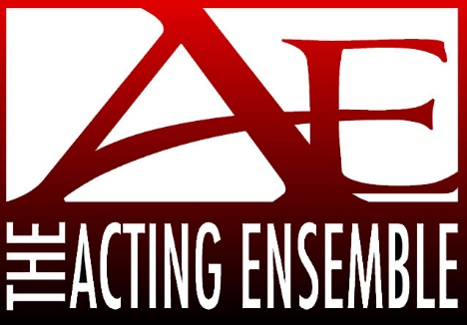

2025 Trivia Night Registration Form

April 5, 2025

“The 1970’s!”

St. Stanislaus Tulip Road., South Bend

Doors open for silent auction at 5:00pm

Trivia starts at 6:00pm

Team Name ______________________ Contact Name __________________

Phone _____________ Email ______________________

$120 for team - up to 8 players Individual Players - $20 each

___Check Enclosed

___ Secure credit card online at <http://www.actingensemble.com/box-office>

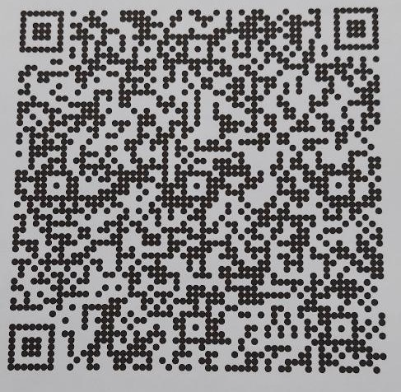

___Venmo to Venmo@ActingEnsemble7

** Remember ALL donations are tax deductible***

Please Return to:

Acting Ensemble Trivia Night

P O Box 756

South Bend, IN 46624

REGISTRATION MUST BE SUBMITTED BY MARCH 30, 2025

574-232-2559 www.actingensemble.com melissa@actingensemble.com