ENSEMBLE ON THE AVENUE **2024 SHORT** SEASON

602 E. Mishawaka Avenue, Mishawaka

[www.actingensemble.com](http://www.actingensemble.com) Curtain time is 7:30pm; 2:00 pm Sundays EST. (574) 217-8873

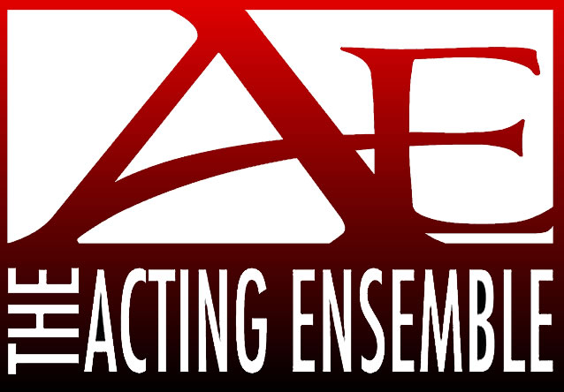

**STAGEWORKS**

(sponsored in part by Erasmus Books)

**7/2/2024 Murder at the Howard Johnsons** by Ron Clark and Sam Bobrick Is all fair in love? Even murder? A light and funny suspense comedy about a love triangle in a Howard Johnson Motor Inn.

**8/6/2024 Ghosts** by Henrik IbsenAn intense, witty and concise adaptation of this harrowing and thrilling 1881 classic which generated strong controversy and criticism and is now considered a play that historically holds a position of immense importance.

**9/3/2024 Admissions** by Joshua HarmonThe admissions head of a New England prep school has fought to diversify the student body. But when her only son sets his sights on an Ivy League university, personal ambition collides with progressive values. A no-holds-barred look at privilege, power, and the perils of hypocrisy.

**10/1/2024 Spider’s Web** by Agatha Christie

This comedy thriller (a conscious parody of the detective thriller in three acts) delivers a unique blend of suspense and humor in an intricate plot of murder, police, drug addicts, invisible ink, hidden doorways and secret drawers.

**11/6/24 (Wednesday) The Making of a Great Moment** by Peter Sinn Nachtrieb Mona and Terry are actors on a mission: to change people’s lives with the power of theater—while traveling by bicycle and camping out on the side of the road. Likely to resonate with anyone who’s ever had doubt about personal life choices.

**12/3/24 Terra Nova** by Ted Tally Drawn from the journals and letters found on the frozen body of Captain Scott, this play blends scenes of the explorer and his men at various stages of their ordeal, with flashbacks of Scott and his young wife and with fateful glimpses of his Norwegian rival, Roald Amundsen, whose party beat him to the South Pole.

Activities are made possible in part by the Community Foundation of St. Joseph County, the Indiana Arts Commission, which receives support from the State of Indiana and the National Endowment for the Arts, and The Harvey R. and Doris Klockow Foundation.

**POETS And PLAYWRIGHTS**

**Tickets available online or at the door** [**http://www.actingensemble.com/box-office**](http://www.actingensemble.com/box-office)

**o**

(sponsored in part by Chris and Dick Currey)

**8/22 – 8/26/2024 12 x 10** by KC Matthews An evening of 12 ten-minute plays, written and directed by local artists and rehearsed and produced in two weeks.



**9/27 – 9/28/2024 Next of Kin** by Kyle Hutslar and Eddie Castle A series of interrelated scary scenes for your spooky pleasure.

**SPECIAL EVENTS**

**6/28/2024 9:00 pm Pride Drag Show**

Come celebrate the month of gay pride – featuring some of our local folks lip syncing some of their favorite tunes! Bring your dollars; bring your friends!

**MAINSTAGE(7 shows each)**

**7/26 – 8/4/24 District Merchants** by Aaron Posner Love, loss, litigation, and predatory lending are examined in surprising ways in this uneasy comedy, which wades fearlessly into the endless complexities and contradictions of life in America. Set among the Black and Jewish populations of an imagined time and place that is simultaneously Shakespearean, Reconstruction-era,

Washington, D.C., and today. District Merchants is a remarkable tale of money, merchandise, and merc

**10/4 – 10/13/24 The Outsider** by Paul Slade Smith From the author of “Unnecessary Farce”. Ned Newley doesn’t even want to be governor. He might be the worst candidate to ever run for office. Unless the public is looking for…the worst candidate to ever run for office. A timely and hilarious comedy that skewers politics and celebrates democracy.

**12/6 – 12/15/2024 The Half-Life of Marie Curie** by Lauren Gunderson

Soon after Marie Curie won the Nobel Prize in Chemistry, she was the object of ruthless gossip and joined her friend and colleague Hertha Ayrton, an electromechanical engineer. This play revels in the power of female friendship as it explores the relationship between these two brilliant women.

*2023/2024 Season Tickets will be honored through December 2024. Beginning in 2025, Acting Ensemble’s season will run from January through December!*